**Creating a Music Box (“Ode to Joy”)**

In this activity, you will require the following:

* Arduino
* Breadboard
* Pushbutton Switch
* One 10000 Ohm Resistor
* Hookup wires
* USB A-B cable

1. Connect our pushbutton to the Arduino by mounting it on the breadboard.
2. Place the 10000 Ohm resistor in the breadboard
3. Hook up the Arduino to the breadboard as in the diagram attached.
4. Connect your Arduino to your computer with the USB A-B cable.

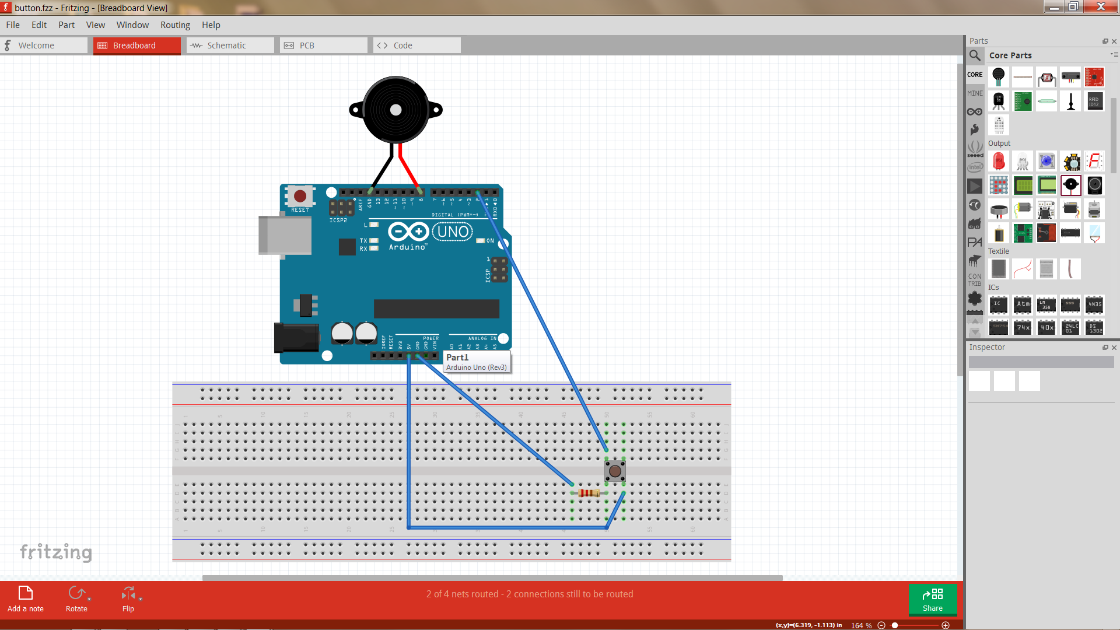

1. (Optional) Make sure Arduino is you can check out device manager to find out what Port we are connected to. You can see this in the Device Manager.

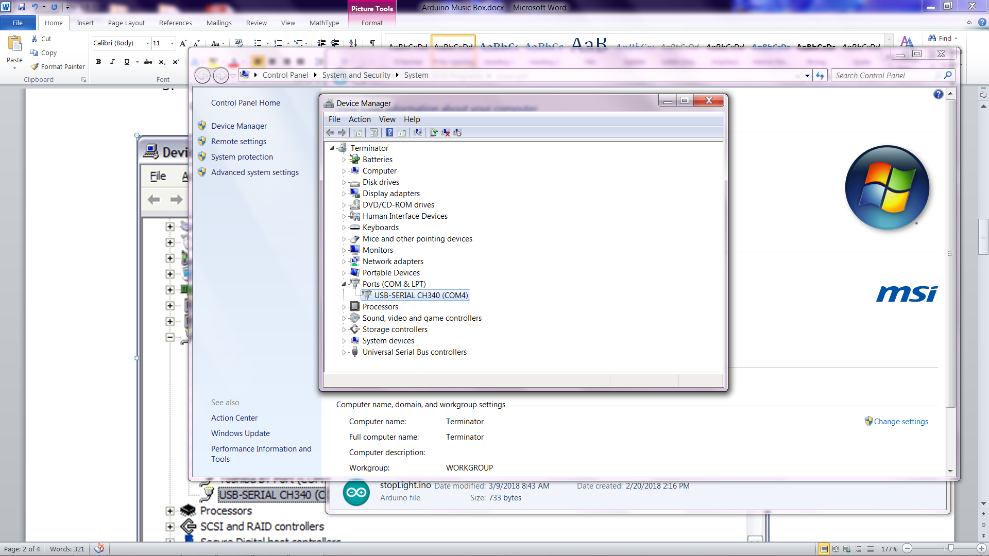

Note: Mine is connected to Port 4 but yours might be different. You should make a note of this.

1. Start your Arduino development environment.
2. On your Tools menu, check that the Board is set to Uno and the Port is set to the value you noted in step 5.

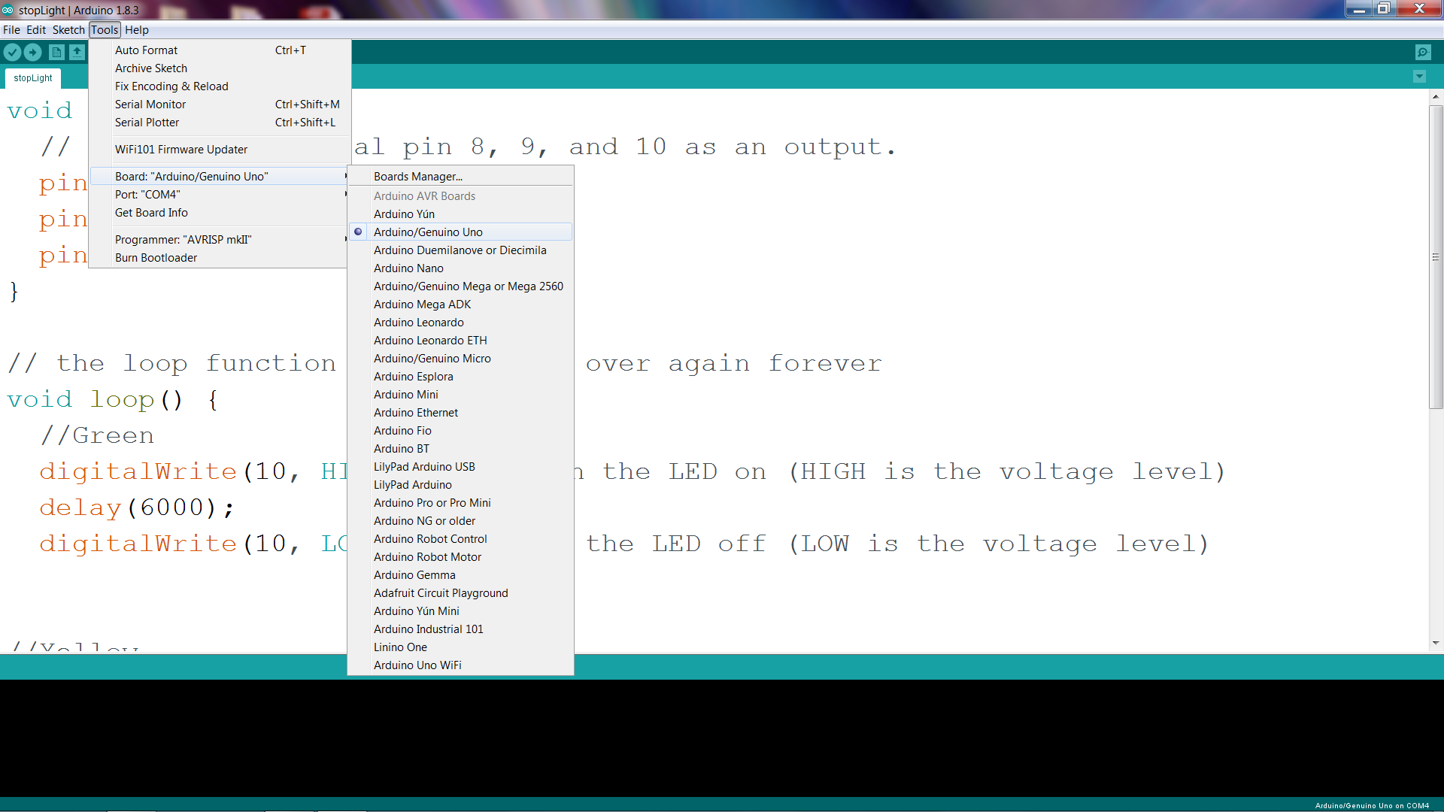

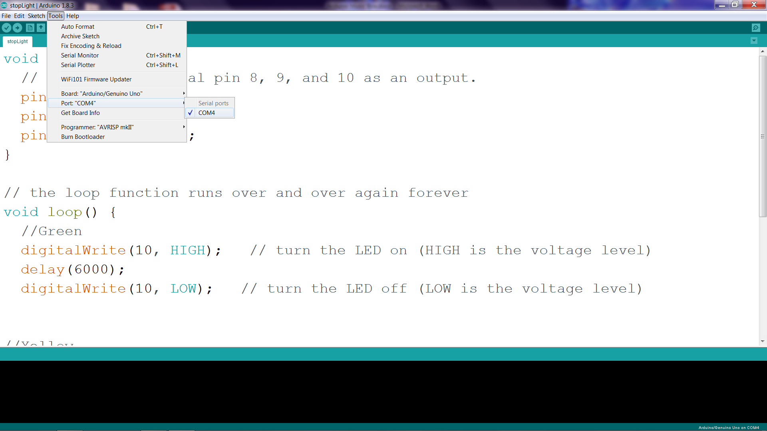

In this program, we will be using two special functions; tone and delay.

The tone function has 3 parameters; pin to send signal to, frequency in Hertz, and duration in milliseconds

The delay function has 1 parameter; time in milliseconds

Now let’s make some music by typing in the following code and running it. Press the button and see what happens. Do you recognize the song?

**Now let’s add the code**

//Plays a melody

const int buttonPin = 2;

int pbState = 0;

void setup(){

pinMode(buttonPin, INPUT);

}

void loop(){

pbState = digitalRead(buttonPin);

if (pbState == HIGH){

//First group of notes

tone(8, 247, 300);

delay(500);

tone(8, 247, 300);

delay(500);

tone(8, 262, 300);

delay(500);

tone(8, 294, 300);

delay(500);

tone(8, 294, 300);

delay(500);

//second group of notes

tone(8, 262, 300);

delay(500);

tone(8, 247, 300);

delay(500);

tone(8, 220, 300);

delay(500);

tone(8, 196, 300);

delay(500);

tone(8, 196, 300);

delay(500);

//third group of notes

tone(8, 220, 300);

delay(500);

tone(8, 247, 300);

delay(500);

tone(8, 247, 500);

delay(650);

tone(8, 220, 200);

delay(250);

tone(8, 220, 200);

delay(250);

}

}